Domain Name: Employee Attendance Management System

Description: The Employee Attendance Management System is an essential part of managing your workforce. It helps keep tabs on when your employees are present, their working hours, and when they take time off. This system aids in handling payroll, assessing performance, and overall managing your team.

Relevance: Keeping track of attendance efficiently ensures that payroll is done accurately, that you comply with labor regulations, and it gives you insights into how your employees work and their productivity.

**Tables**

**Employee: Stores Employee Details**

Attributes: EmployeeID (Primary Key), Name, Address, Phone, Email, JobTitle, DepartmentID (Foreign Key)

Data Types: VARCHAR, VARCHAR, VARCHAR, VARCHAR, VARCHAR, VARCHAR, VARCHAR

Constraints: NOT NULL, UNIQUE (EmployeeID, Email)

**Department: Stores Department Details**

Attributes: DepartmentID (Primfloaary Key), DepartmentName

Data Types: VARCHAR, VARCHAR

Constraints: NOT NULL, UNIQUE (DepartmentID, DepartmentName)

**Attendance: Stores Attendance Details for that day**

Attributes: AttendanceID (Primary Key), EmployeeID (Foreign Key), Date, CheckInTime, CheckOutTime, NoOfHoursWorked

Data Types: VARCHAR, VARCHAR, DATE, TIME, TIME, TIME

Constraints: NOT NULL

**Leave: Stores Leave Details**

Attributes: LeaveID (Primary Key), EmployeeID (Foreign Key), LeaveType, StartDate, EndDate

Data Types: VARCHAR, VARCHAR, VARCHAR, DATE, DATE

Constraints: NOT NULL

**Shift: Stores the shift details of employees**

Attributes: ShiftID (Primary Key), EmployeeID (Foreign Key), StartTime, EndTime, BreakTime

Data Types: VARCHAR, VARCHAR, TIME, TIME, TIME

Constraints: NOT NULL

**Overtime: Stores the overtime details of employees**

Attributes: OvertimeID (Primary Key), EmployeeID (Foreign Key), Date, NumberOfHours, Reason

Data Types: VARCHAR, VARCHAR, DATE, TIME, VARCHAR

Constraints: NOT NULL

**Holiday: Stores the Holiday Details**

Attributes: HolidayID (Primary Key), Name, Date, IsPaid

Data Types: VARCHAR, VARCHAR, DATE, BOOLEAN

Constraints: NOT NULL

**AttendanceLog: Stores the attendance details for everyday**

Attributes: LogID (Primary Key), EmployeeID (Foreign Key), Date, Status, TotalHoursWorked

Types: VARCHAR, VARCHAR, DATE, VARCHAR, TIME

Constraints: NOT NULL

**E-R Diagram**

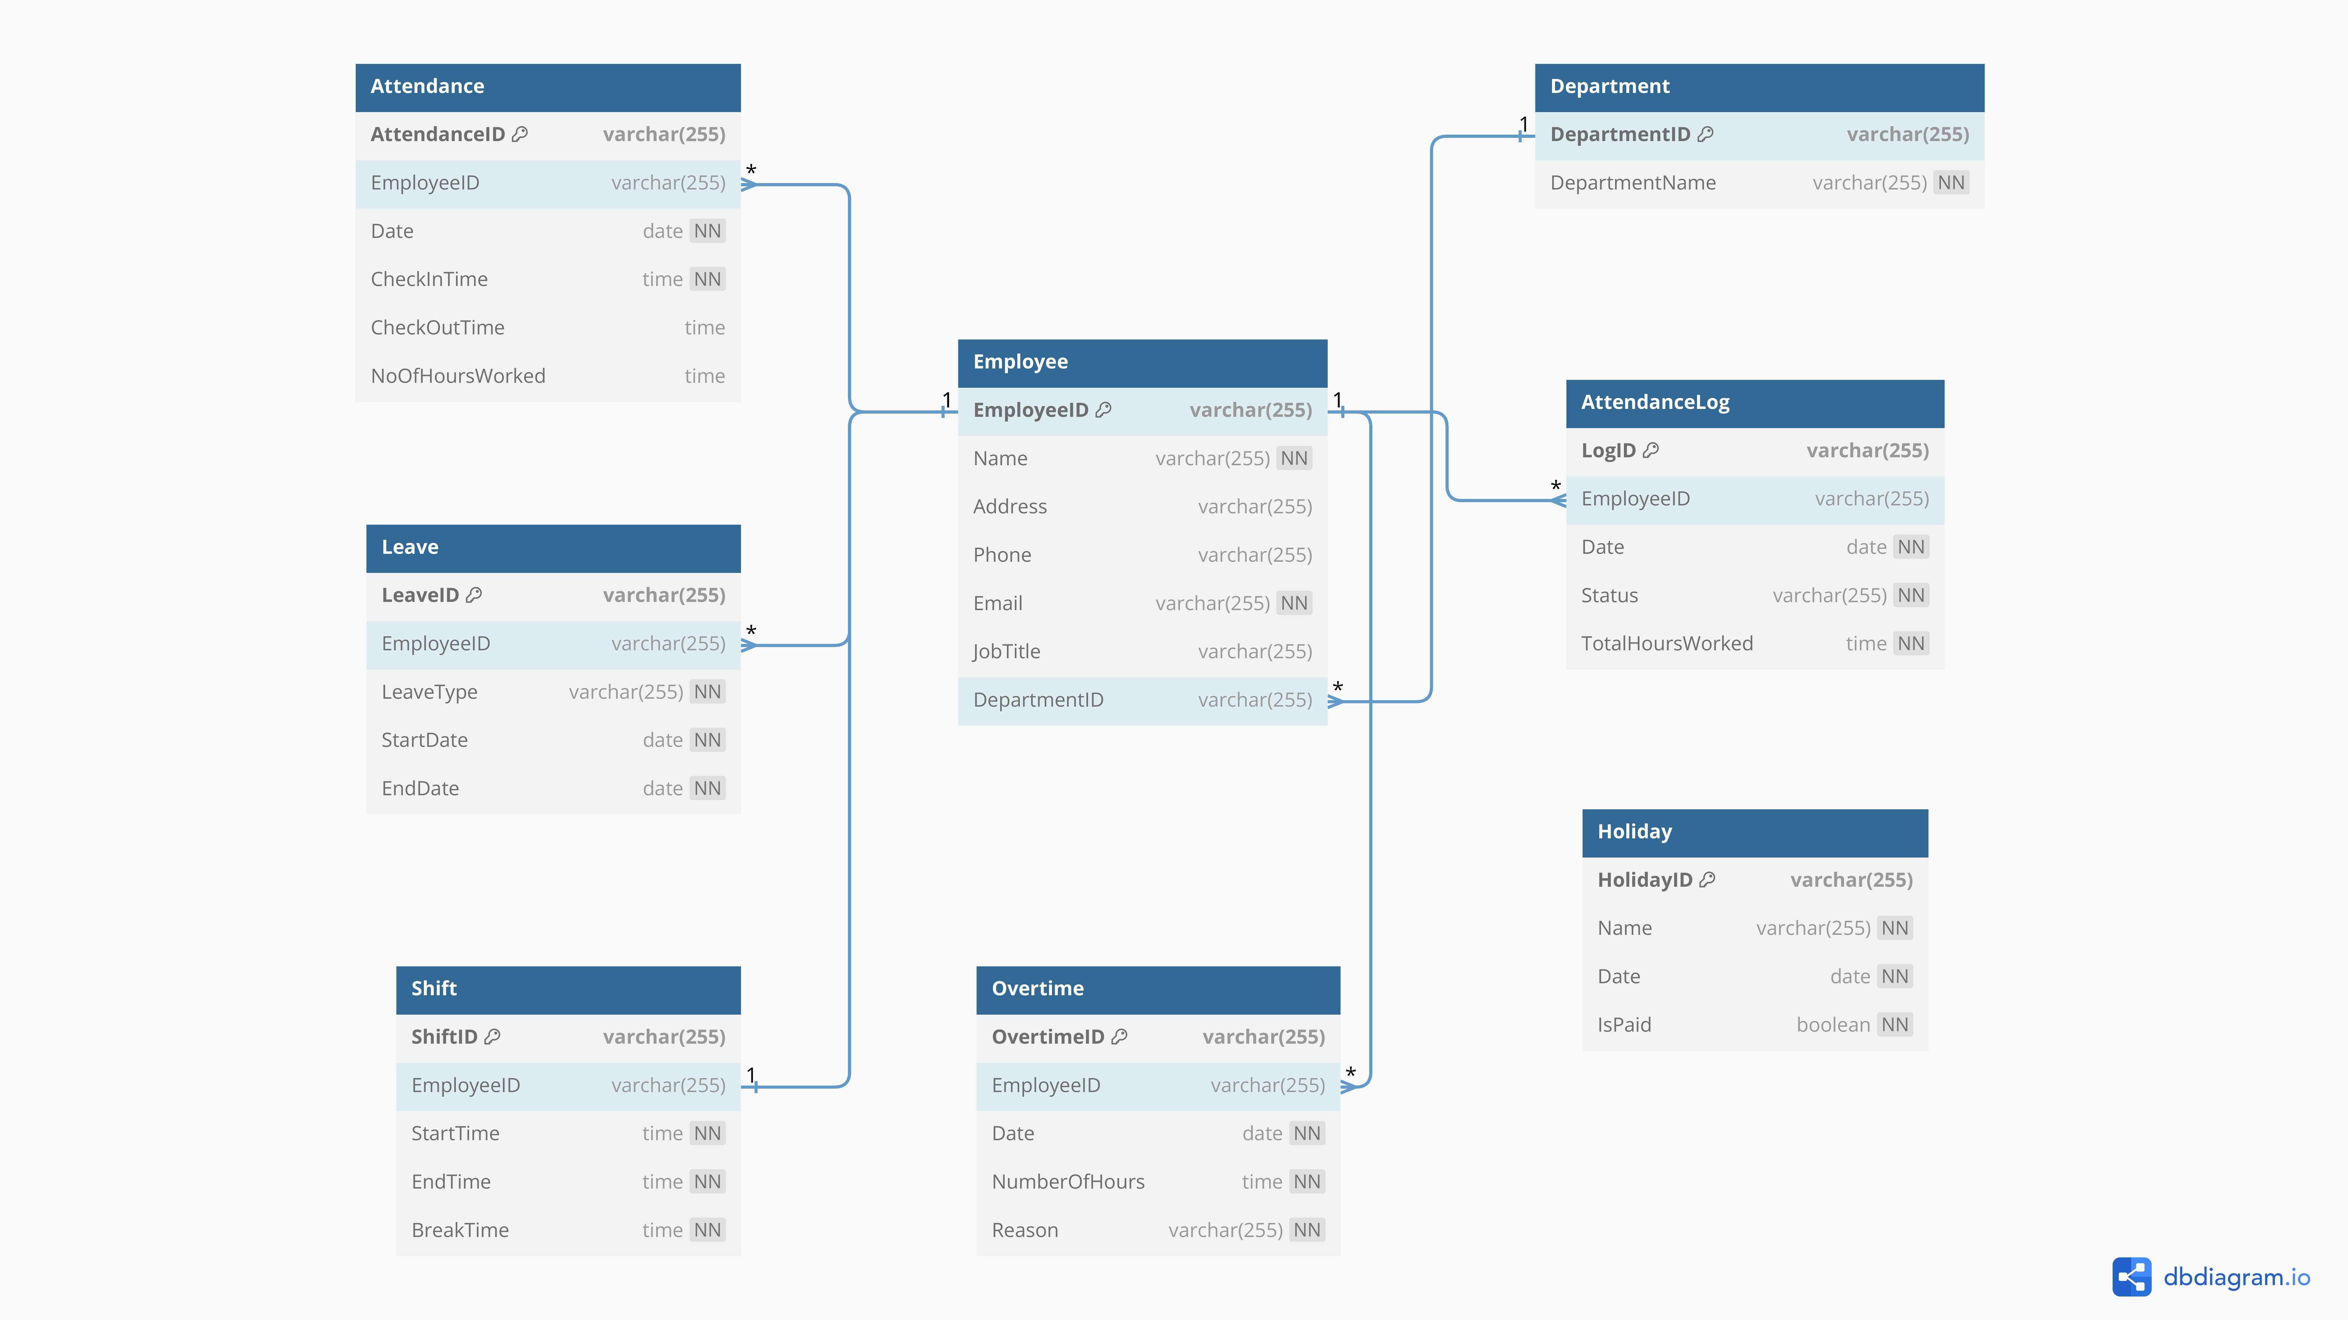

**Normalized Tables**

EMPLOYEE

|  |  |  |  |  |  |  |
| --- | --- | --- | --- | --- | --- | --- |
| EmployeeID | Name | Address | Phone | Email | JobTitle | DepartmentID |
| E001 | John Doe | 123 Main St, City | 555-1234 | john.doe@email.com | Software Engineer | D001 |
| E002 | Jane Smith | 456 Oak Ave, Town | 555-5678 | jane.smith@email.com | HR Specialist | D002 |
| E003 | Robert Johnson | 789 Pine Rd, Village | 555-9876 | robert.j@email.com | Marketing Manager | D004 |
| E004 | Sarah Brown | 101 Elm Blvd, Metropolis | 555-4321 | sarah.brown@email.com | Sales Executive | D004 |
| E005 | Alex Turner | 202 Cedar Lane, Suburb | 555-8765 | alex.turner@email.com | IT Manager | D001 |
| E006 | Emma White | 555 Birch Street, Town | 555-3456 | emma.white@email.com | Accountant | D003 |
| E007 | David Miller | 789 Oakwood Drive, City | 555-7890 | david.miller@email.com | Project Manager | D005 |
| E008 | Olivia Lee | 321 Maple Ave, Suburb | 555-2345 | olivia.lee@email.com | Marketing Specialist | D004 |
| E009 | Michael Wilson | 456 Pine Street, Village | 555-6789 | michael.wilson@email.com | Data Analyst | D002 |
| E010 | Sophia Davis | 987 Cedar Lane, Town | 555-1236 | sophia.davis@email.com | Software Developer | D001 |

DEPARTMENT

|  |  |
| --- | --- |
| DepartmentID | DepartmentName |
| D001 | IT Department |
| D002 | HR Department |
| D003 | Finance Department |
| D004 | Marketing Department |
| D005 | Operations Department |

ATTENDANCE

|  |  |  |  |  |  |
| --- | --- | --- | --- | --- | --- |
| AttendanceID | EmployeeID | Date | CheckInTime | CheckOutTime | NoOfHoursWorked |
| A001 | E001 | 2023-12-16 | 09:00:00 | 13:00:00 | 04:00:00 |
| A002 | E001 | 2023-12-16 | 14:00:00 | 18:00:00 | 04:00:00 |
| A003 | E002 | 2023-12-16 | 09:04:00 | 18:32:00 | 09:28:00 |
| A004 | E003 | 2023-12-16 | 10:00:00 | 18:00:00 | 08:00:00 |
| A005 | E004 | 2023-12-16 | 09:10:00 | 13:15:00 | 04:05:00 |
| A006 | E004 | 2023-12-16 | 14:00:00 | 18:00:00 | 04:00:00 |
| A007 | E005 | 2023-12-16 | 09:00:00 | 13:00:00 | 04:00:00 |
| A008 | E005 | 2023-12-16 | 09:00:00 | 13:00:00 | 04:00:00 |
| A009 | E006 | 2023-12-16 | 09:00:00 | 18:00:00 | 09:00:00 |
| A010 | E007 | 2023-12-16 | 10:00:00 | 17:30:00 | 07:30:00 |
| A011 | E008 | 2023-12-16 | 09:00:00 | 18:00:00 | 09:00:00 |
| A012 | E009 | 2023-12-16 | 09:15:00 | 13:00:00 | 03:45:00 |
| A013 | E009 | 2023-12-16 | 14:00:00 | 18:00:00 | 04:00:00 |
| A014 | E010 | 2023-12-16 | 10:00:00 | 18:45:00 | 09:45:00 |

LEAVE

|  |  |  |  |  |
| --- | --- | --- | --- | --- |
| LeaveID | EmployeeID | LeaveType | StartDate | EndDate |
| L001 | E001 | Vacation | 2023-12-18 | 2023-12-27 |
| L002 | E002 | Sick | 2023-12-19 | 2023-12-20 |
| L003 | E005 | Personal | 2023-12-21 | 2023-12-22 |
| L004 | E009 | Vacation | 2023-12-20 | 2023-12-30 |

SHIFT

|  |  |  |  |  |
| --- | --- | --- | --- | --- |
| ShiftID | EmployeeID | StartTime | EndTime | BreakTime |
| S001 | E001 | 09:00:00 | 18:00:00 | 13:00:00 – 14:00:00 |
| S002 | E002 | 09:00:00 | 18:00:00 | 13:00:00 – 14:00:00 |
| S003 | E003 | 09:00:00 | 18:00:00 | 13:00:00 – 14:00:00 |
| S004 | E004 | 09:00:00 | 18:00:00 | 13:00:00 – 14:00:00 |
| S005 | E005 | 09:00:00 | 18:00:00 | 13:00:00 – 14:00:00 |
| S006 | E006 | 09:00:00 | 18:00:00 | 13:00:00 – 14:00:00 |
| S007 | E007 | 09:00:00 | 18:00:00 | 13:00:00 – 14:00:00 |
| S008 | E008 | 09:00:00 | 18:00:00 | 13:00:00 – 14:00:00 |
| S009 | E009 | 09:00:00 | 18:00:00 | 13:00:00 – 14:00:00 |
| S010 | E010 | 09:00:00 | 18:00:00 | 13:00:00 – 14:00:00 |

OVERTIME

|  |  |  |  |  |
| --- | --- | --- | --- | --- |
| OvertimeID | EmployeeID | Date | NumberOfHours | Reason |
| OT001 | E03 | 2023-12-12 | 02:30 | Meeting |
| OT002 | E05 | 2023-12-13 | 01:45 | Project Deadline |
| OT003 | E06 | 2023-12-10 | 03:00 | Client Presentation |
| OT004 | E08 | 2023-12-15 | 02:15 | Year-End Review |

HOLIDAY

|  |  |  |  |
| --- | --- | --- | --- |
| HolidayID | Name | Date | IsPaid |
| H001 | Republic Day | 2023-01-26 | true |
| H002 | Holi | 2023-03-17 | true |
| H003 | Eid al-Fitr | 2023-04-23 | true |
| H004 | Eid al-Adha | 2023-07-31 | true |
| H005 | Independence Day | 2023-08-15 | true |
| H006 | Ganesh Chaturthi | 2023-09-05 | true |
| H007 | Gandhi Jayanti | 2023-10-02 | true |
| H008 | Dussehra | 2023-10-08 | true |
| H009 | Diwali | 2023-10-19 | true |
| H010 | Christmas | 2023-12-25 | true |

ATTENDANCE_LOG

|  |  |  |  |  |
| --- | --- | --- | --- | --- |
| LogID | EmployeeID | Date | Status | TotalHoursWorked |
| Log001 | E001 | 2023-12-16 | Present | 08:00:00 |
| Log002 | E002 | 2023-12-16 | Present | 09:28:00 |
| Log003 | E003 | 2023-12-16 | Present | 08:00:00 |
| Log004 | E004 | 2023-12-16 | Present | 08:05:00 |
| Log005 | E005 | 2023-12-16 | Present | 08:00:00 |
| Log006 | E006 | 2023-12-16 | Present | 06:30:00 |
| Log007 | E007 | 2023-12-16 | Present | 08:00:00 |
| Log008 | E008 | 2023-12-16 | Present | 08:00:00 |
| Log009 | E009 | 2023-12-16 | Present | 7:45:00 |
| Log010 | E010 | 2023-12-16 | Present | 07:30:00 |